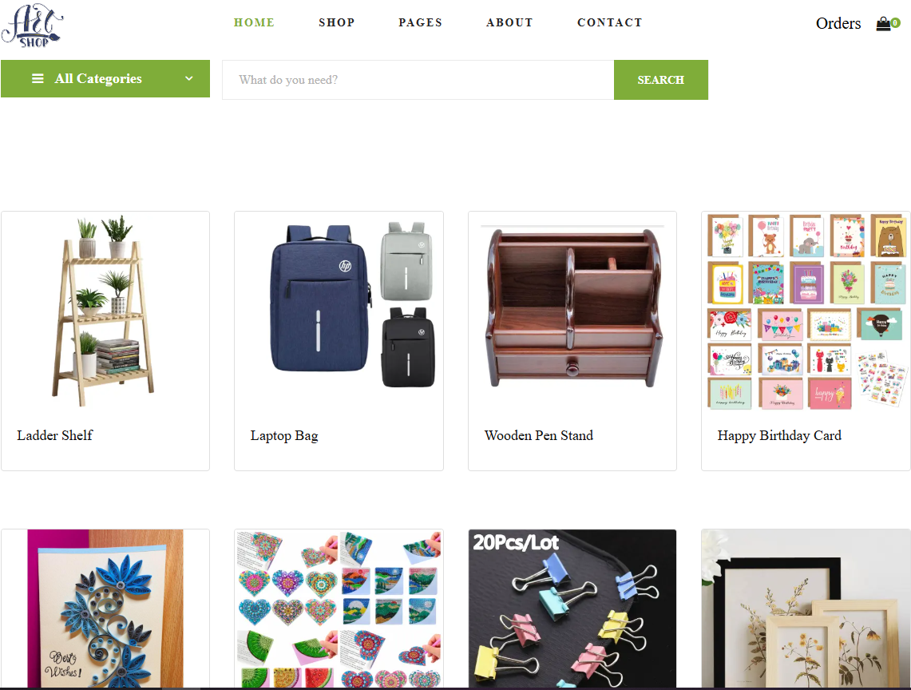

***" Your Ultimate school stationary sellers!"***

***ART shop***

**MENTOR: SIR RIZWAN**

**TEAM MEMBERS:**

Mr Muhammad Touqeer Haider

Shehran Ahmed

Mr Muhammad Mudasir

Mr

# TABLE OF CONTENT

Contents

TABLE OF CONTENT 18

1.1 ACKNOWLEDGE 21

1.2 BACKGROUND 22

1.3 PROJECT SYNOPSIS 24

1.4 REQUIREMENT SPECIFICATIONS: 25

1.5 PROBLEMS STATEMENT 26

1.6 CONSTRAINS 26

1.7 FUNCTIONAL REQUIREMENT: 27

Contact us: 29

Sitemap: 29

1.8 INTERFACE REQUIREMENT 30

Hardware 30

Software 30

1.9 WEBSITE FEATURES 31

2.0 Website Design Features 31

2.1 Flow diagram 32

2.2 Architectural Diagram 33

HOME 34

ABOUT 35

CONTACT 36

CATALOGUE 37

Admin panel: 37

2.3 USER GUIDE 39

TASK SHEET 40

# 1.1 ACKNOWLEDGE

First of all we would like to thank Almighty Allah for giving us strength and ability to complete this project.

And then, we would like to express my special thanks of gratitude to our Sir Rizwan Tahir who guided us on the project Ecommerce website, which also helped us in doing a lot of new learning and we came to know about so many new things we are really thankful to him.

We are highly thankful to Sir Rizwan Tahir for his guidance and constant supervision as well as for providing necessary information regarding the project & also for his support in completing the project.

Lastly, we would also like to thank our parents and friends who helped us a lot in finalizing this project within the limited time frame. We earnestly hope that this project will provide all the necessary information required by the user to fulfil his inspiration. However, suggestion and Feedbacks for improvements will be thankfully welcomed & acknowledged.

# 1.2 BACKGROUND

The necessity for **Art Shop** stems from several factors related to the increasing demand for convenient shopping, the growing preference for online purchasing, and the need for a one-stop platform for all school-related stationery supplies. Here are the key reasons why such a website is essential:

* **Growing Interest in Education and School Supplies**:

With the increasing focus on education and the need for students and educators to stay well-equipped, there is a consistent demand for school supplies. A **School Stationery Ecommerce Website** provides a platform for parents, students, and schools to easily access and purchase the required stationery items for their academic needs.

* **Trend**: Parents and schools are looking for an efficient way to shop for a wide range of stationery supplies, from pens and notebooks to backpacks and calculators.
* **Challenge**: Locating quality school supplies from different vendors can be time-consuming and tedious. A dedicated ecommerce platform solves this by offering all necessary items in one place.

**❖ Convenience of Online Shopping:**

Instead of visiting multiple physical stores or browsing through various websites, an ecommerce platform that consolidates all aspects of school stationery—such as writing instruments, paper products, backpacks, art supplies, and more—saves significant time and effort for users.

* **Convenience**: Users can browse a variety of products, check availability, compare prices, and make secure purchases from the comfort of their homes.
* **Time-Saving**: Online shopping eliminates the need for long in-store visits and provides quick access to items with just a few clicks.

* **Personalized Recommendation:**

A well-designed **Arts Shop Website** can offer personalized suggestions based on user preferences, past purchases, or specific educational requirements. For example, it can recommend premium quality notebooks for high school students, eco-friendly options for environmentally-conscious families, or themed supplies for younger children.

* **Tailored Shopping**: The website can suggest products that suit the user’s specific needs—whether it’s the best notebooks for a certain grade, or specialized tools for specific educational tasks.
* **Discover New Products**: Personalized recommendations can help users discover new products they may not have considered before, enhancing the shopping experience.
* **Cost Efficiency:**

One of the major advantages of an ecommerce platform is the ability to **compare prices** across different suppliers and find the best deals on school stationery items, including discounts, bulk offers, and promotions.

* **Price Comparison**: Users can quickly compare the costs of notebooks, pens, backpacks, and other supplies across various vendors, helping them save money while ensuring quality.
* **Discounts and Bundles**: The website can offer special discounts for bulk purchases or back-to-school promotions, helping families save money during peak seasons.

**❖ Real-Time Updates:**

A **School Stationery Ecommerce Website** can provide real-time information on product availability, delivery schedules, stock updates, and any ongoing sales or promotions. Additionally, it can offer timely information on order status, shipment tracking, and delivery updates.

* **Stock Updates**: Users are informed in real-time when a product is back in stock or when an item is running low, reducing frustration from out-of-stock products.
* **Shipping and Delivery Information**: Customers can track their orders in real-time, and receive updates on estimated delivery dates, so they can plan accordingly.

❖ **Mobile Accessibility:**

With many users planning and buying stationary, a mobile-friendly Art Shop Website ensures accessibility and convenience from any device.

# 1.3 PROJECT SYNOPSIS

The **Arts Shop** is designed to meet the diverse needs of a wide range of customers, from parents purchasing school supplies for their children to teachers and educational institutions seeking bulk stationery. The website serves as an all-encompassing platform, allowing users to **easily browse, compare, and purchase school supplies**, including everyday essentials such as pens, notebooks, and backpacks, as well as specialty items like calculators, art supplies, and classroom tools.

In addition, the website offers **personalized product recommendations** based on user preferences, such as age group, grade level, and specific educational requirements. This personalization ensures that customers can easily find exactly what they need, whether they're shopping for a young child in primary school or a high school student preparing for exams.

Just as travelers have different preferences based on their destinations or travel style, **customers of the Arts Shop Website** have unique needs depending on their role and educational requirements. Whether they are **parents** shopping for back-to-school supplies, **students** seeking specific items for their studies, or **teachers** looking to stock up on classroom materials, the website delivers a tailored, **user-friendly shopping experience** that caters to everyone’s individual needs.

By **segmenting customers into specific categories**, such as **primary school students**, **high school students**, **teachers**, and **parents**, the website is able to provide **relevant products** and **customized recommendations**, simplifying the search process for each customer. Whether the customer is looking for **affordable options**, **eco-friendly products**, or **premium brands**, the School Stationery Ecommerce Website ensures that they find exactly what they need, all in one place.

This platform is not just about selling stationery; it's about creating an **enjoyable and efficient shopping experience** that makes purchasing school supplies easier, faster, and more accessible for all. The website aims to provide the best solutions for every customer, whether they are shopping for everyday school needs or preparing for a special educational project or event.

# 1.4 REQUIREMENT SPECIFICATIONS:

* Maintaining the product details, stock details, order, and delivery details of the products and that of the customers are to be maintained with the help of the database.
* There should be separate login for Admin and customer.

# 

# 1.5 PROBLEMS STATEMENT

One of the common issues when purchasing school supplies online is **unexpected stock shortages**, **delays in shipping**, or **price fluctuations** that can create inconvenience for customers. For example, when items are out of stock or shipping times unexpectedly increase, it can disrupt a parent or teacher’s plans to get the necessary materials for the school year. Additionally, **unexpected price hikes** or **limited availability of items** may indicate high demand during back-to-school seasons, creating frustration for customers trying to meet school deadlines.

An **automatic detection and alert system** is crucial for a **Art Shop Ecommerce Website** to address these challenges. This feature can notify users of **real-time inventory changes**, **shipping delays**, or **price updates**, allowing them to make adjustments to their orders, explore alternative options, and avoid inconvenience. For example, if an item goes out of stock or there are shipping delays, the website can automatically suggest **alternative products** or **adjusted delivery dates** to ensure a smooth shopping experience.

.

# 1.6 CONSTRAINS

The **Art Shop Ecommerce Website** has some limitations in terms of how it stores and manages information:

* **Limited Interactivity with Backend**: While users can view and interact with the data presented on the site, any changes, such as product inventory updates or user-generated content (like reviews or custom orders), must be handled externally. This limitation ensures the website remains lightweight but also means that features like real-time inventory updates or order tracking require careful management on the backend.

Despite these constraints, the **Art shop Ecommerce Website** will still deliver a highly functional and user-friendly experience by pulling in dynamic, up-to-date data from external sources, ensuring that customers can browse and purchase products efficiently

# 

# 1.7 FUNCTIONAL REQUIREMENT:

The **Art Shop Ecommerce Website** will be built with the following functional requirements to provide a seamless, user-friendly shopping experience. The website will be designed as a **responsive, visually appealing platform** that adjusts for various devices and screen sizes, ensuring ease of access whether the user is on a desktop, tablet, or mobile device.

# Product Catalogue:

* **Detailed Product Listings**: Users will be able to view detailed information about various school stationery items, including **descriptions**, **prices**, **images**, and **special offers**.
* **Product Categories**: The website will display products across several categories, such as **writing instruments**, **notebooks**, **art supplies**, **backpacks**, and more.
* **Special Offers**: Each product listing may include promotions, such as **discounts**, **bundled offers**, and **seasonal sales**.

# Product Search and Navigation:

* **Search Functionality**: Users will be able to search for specific products using **keywords** (e.g., "blue pens," "graphing calculator") or by browsing through product categories.
* **Category Navigation**: Clear navigation options will allow users to easily browse products based on categories like **primary school**, **high school**, **teachers**, or **eco-friendly options**.

**About Us:**

* **Company Information**: The website will feature a section with a **brief introduction to the platform**, including its **mission**, **values**, and the **story behind the company**.
* **Customer Support**: Information about how the company supports its customers, including return policies and product guarantees.

# Contact Us:

* **Contact Information**: The website will provide easy-to-find **contact details**, such as an **email address** and **customer service phone number** for inquiries and support.
* **Geolocation**: For users who may want to visit physical stores, the website may include **GPS/geolocation** functionality to find nearby locations.

# Shopping Cart & Checkout:

* **Shopping Cart**: Users can easily add products to their shopping cart, view the items, and modify quantities.
* **Checkout Process**: The checkout page will allow users to review their order, select payment options, and finalize the purchase.

# Sitemap:

* **Clear Website Structure**: A **sitemap** will be included to help users navigate through the website’s sections, making it easy to find the products or information they need.

**Hardware/ Software Requirements**

**Hardware**

* A minimum computer system that will help you access all the tools in the courses is a Pentium 166 or better
* 128 Megabytes of RAM or better

**Operating System**

* LINUX / Windows 2000 Server (or higher if possible)

**Software**

* PHP
* MySQL
* PERL
* Apache

# 1.9 WEBSITE FEATURES

The **Art shop Website** is designed to provide an all-in-one shopping experience for users looking to purchase school supplies. The website features a comprehensive catalogue of **school stationery products**, ranging from basic essentials like **pens, pencils, and notebooks** to specialized items such as **art supplies, backpacks, and calculators**. Each product is presented with detailed descriptions, high-quality images, and pricing information, making it easy for users to find what they need.

Key features of the website include:

* **Product Search Function**: Users can search for specific products by keywords or categories (e.g., "blue pens," "school bags," "eco-friendly notebooks"). This feature helps users quickly find exactly what they're looking for.
* **Sorting and Filtering Options**: The website offers sorting and filtering functionality, allowing users to organize products by **price**, **popularity**, **grade level**, or **brand**. This ensures users can narrow down their choices and find products that fit their budget, preferences, and educational needs.

The user-friendly design and **responsive interface** ensure that customers can easily shop across different devices, whether they’re using a desktop, tablet, or smartphone. Sections dedicated to **shipping information**, **customer reviews**, and **promotions** are easily accessible, making it simpler for users to complete their purchases without any hassle.

# 2.0 Website Design Features

The **Art Shop Website** is designed with a focus on visual appeal, making it both functional and engaging for users. The layout highlights the beauty of the products, using **high-quality images** and **clear product descriptions** to showcase each item’s features. This design not only provides essential information but also enhances the user experience, helping shoppers make confident choices for their school supply needs.

* **Engaging Visual Design**: The website uses vibrant, attractive imagery to display products, such as colorful pens, notebooks, and classroom supplies. These images help to capture the essence of each product while also making the shopping experience more enjoyable.
* **Intuitive Navigation**: The website layout is simple and easy to navigate, ensuring users can quickly find what they’re looking for. Whether they’re shopping for **back-to-school items** or looking for **bulk purchases** for a classroom, the design ensures that every section of the site is accessible with minimal effort.
* **Interactive Product Pages**: Each product page is designed to provide users with detailed specifications, high-quality images, customer reviews, and related product suggestions. This helps to guide purchasing decisions and improves the overall shopping experience.

By focusing on **user-centric design** and **responsive functionality**, the **Art Shop Website** not only provides essential school supplies but also creates an enjoyable, efficient shopping experience for parents, teachers, and students alike. Whether shopping for a single item or preparing for an entire school year, the design ensures users can easily browse, compare, and purchase the products they need.

# 2.1 Flow diagram

# 2.2 Architectural Diagram

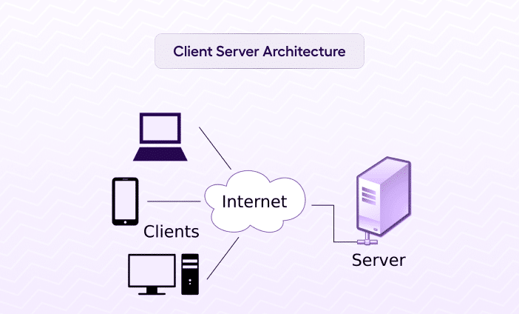

|  |  |  |
| --- | --- | --- |
|  |  |  |

# HOME

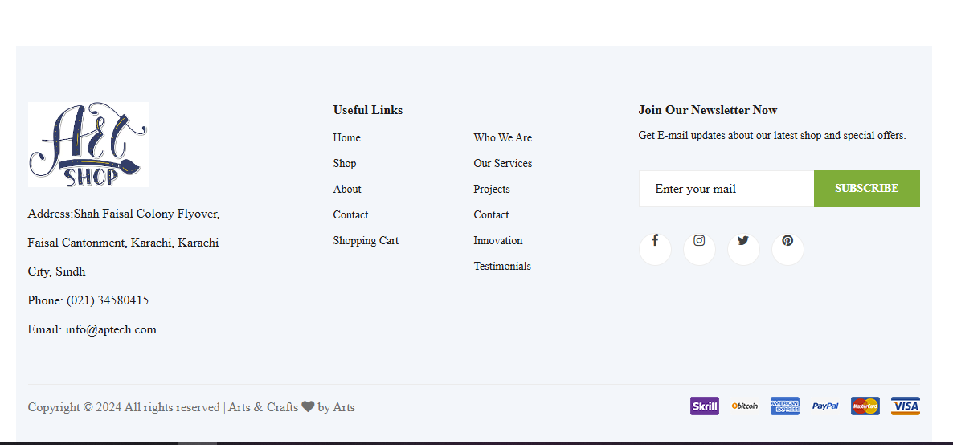

**ABOUT *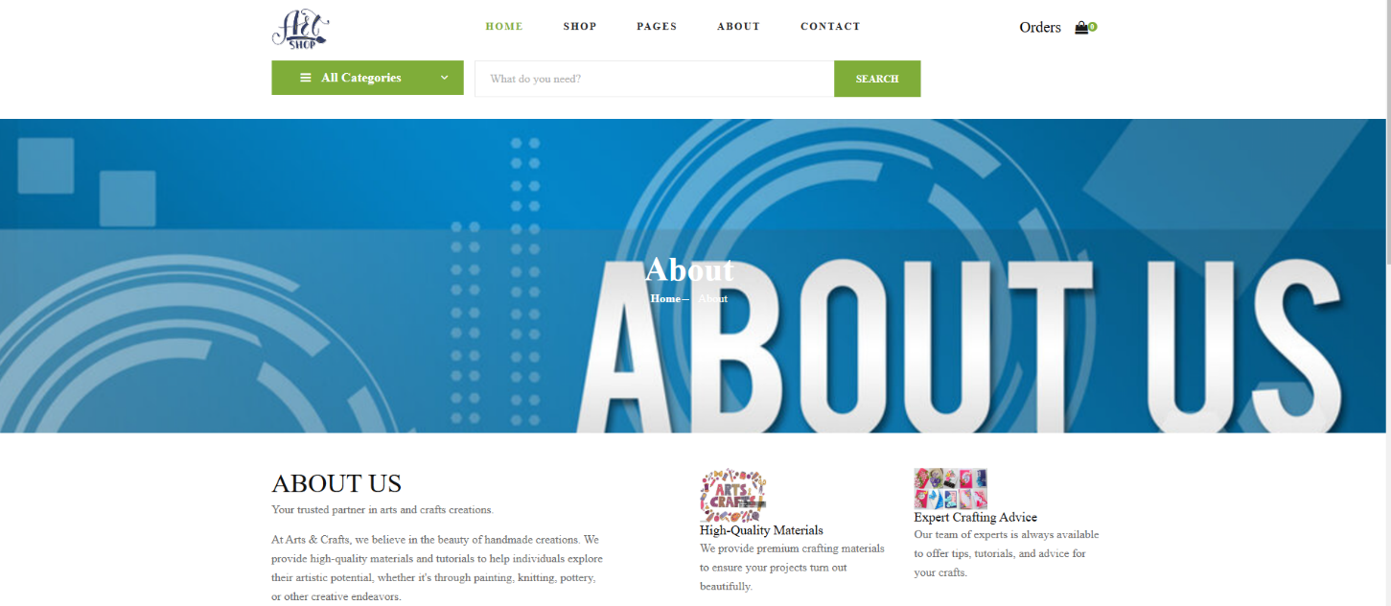***

**CONTACT** 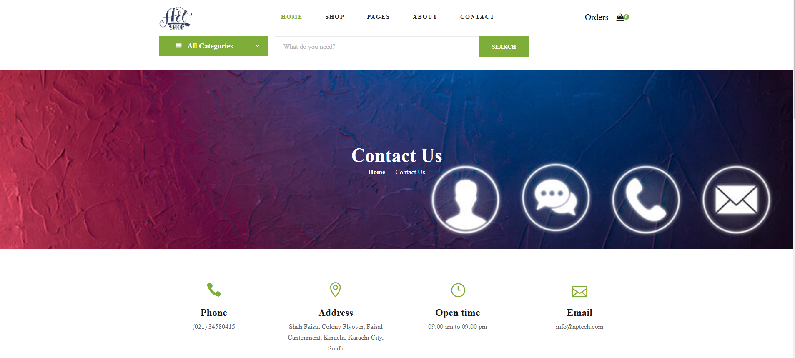

# Admin panel

# 

# 

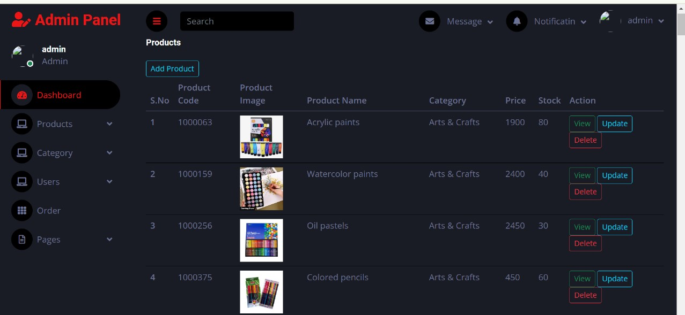

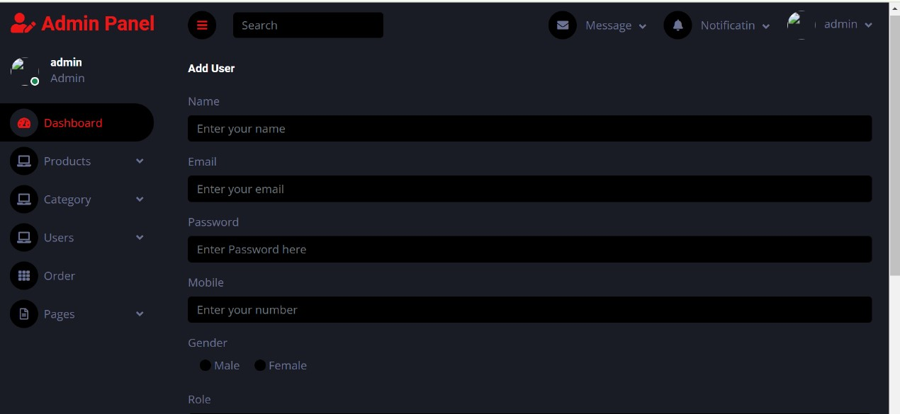

# 

# 

# 

# (Admin panel id :[admin@gmail.com] password:[0000])

# ER diagram

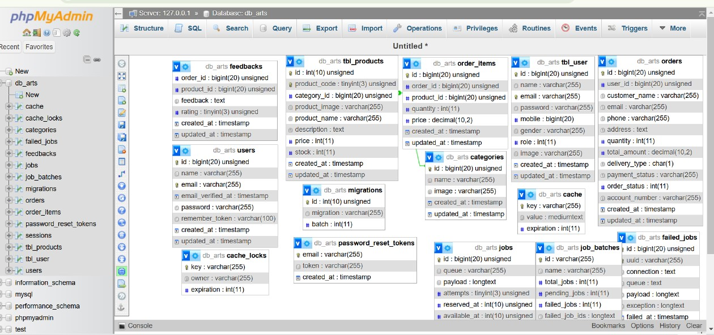

# 2.3 USER GUIDE

**Why Do You Need a User Manual for Your stationary order?**

A user guide for the **School Stationery Ecommerce Website** is essential to help customers navigate the site and fully understand how to make the most of its features. Whether shopping for **back-to-school supplies**, **classroom materials**, or **specialty stationery**, the guide will ensure a smooth, hassle-free shopping experience. Here’s why a user manual is an important part of the website:

1. **Boosts Productivity** A **well-structured user manual** can reduce confusion and help customers quickly find what they’re looking for, without needing to contact support. By offering step-by-step instructions for features like **adding items to the shopping cart**, **applying discount codes**, or **choosing the best shipping options**, the guide helps users make their purchases efficiently
2. **Serves as a Reference Guide** The user guide not only helps customers but can also act as a **reference tool** for your support team. When customers need assistance, support staff can refer to the manual to provide quick and accurate help. This is especially useful for common inquiries like **order tracking**, **payment options**, or **product availability**. With a **clear table of contents** and **searchable sections**, both customers and support representatives can easily find answers to their questions.
3. **Reduces Support Inquiries** By providing a **detailed, easy-to-follow user manual**, customers can **self-serve** for many common issues, such as:
4. How to **search for products**
5. How to **filter product categories**
6. **Checking out** and **making payments**
7. Understanding **shipping options** and **delivery times**
8. This will significantly reduce the number of support inquiries and allow your customer support team to focus on more complex issues, improving both efficiency and customer satisfaction.
9. **Improves User Experience** A well-crafted **user guide** helps users navigate the website with ease, making their shopping experience enjoyable and frustration-free. Whether they’re a **parent** shopping for **school supplies**, a **teacher** ordering **bulk materials**, or a **student** purchasing **specialty items**, the manual ensures they have all the information they need to complete their purchase. This enhanced user experience leads to increased **customer satisfaction**, **repeat visits**, and **higher customer retention**, ultimately helping your website build a loyal customer base.